Про рыбок.

Общая инфа о рыбке.

Also known as the big spotted triggerfish. Inhabits outer reef areas and feeds upon crustaceans and mollusks by crushing them with powerful teeth. They are voracious eaters, and divers report seeing the clown triggerfish devour beds of pearl oysters.

Do not eat this fish. According to an 1878 account, "the poisonous flesh acts primarily upon the nervous tissue of the stomach, occasioning violent spasms of that organ, and shortly afterwards all the muscles of the body. The frame becomes rocked with spasms, the tongue thickened, the eye fixed, the breathing laborious, and the patient expires in a paroxysm of extreme suffering."

Not edible.

Range is Indo-Pacific and East Africa to Somoa.

Картинка рыбки:

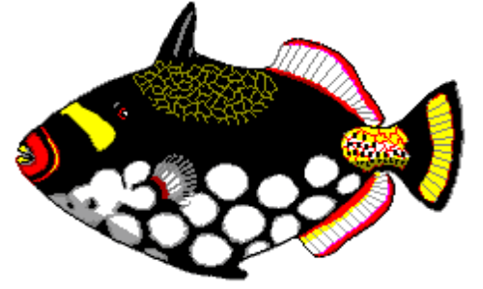

Общая инфа о рыбке.

Called seaperch in Australia. Inhabits the areas around lagoon coral reefs and sandy bottoms.

The red emperor is a valuable food fish and considered a great sporting fish that fights with fury when hooked. The flesh of an old fish is just as tender to eat as that of the very young.

Range is from the Indo-Pacific to East Africa.

Картинка рыбки:

